

**Dolgin Debuts a 4-Position Battery Charger for JVC GY-HM600/650 Cameras** April 22, 2013

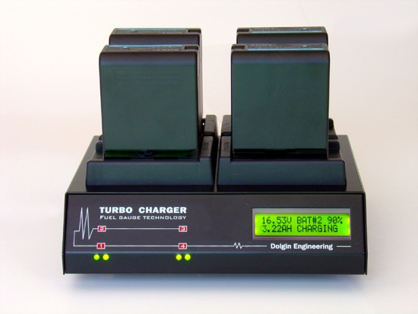**Lexington, MA** – Dolgin Engineering is expanding its line-up of 7.2V battery chargers by introducing the TC400-JVC-650, a fast 4-position microprocessor based battery charger for SSL-JVC50 and SWIT S-8I50 battery packs.

Designed for field newsgathering operations, video production studios and rental facilities, the unit is designed to provide fast, reliable charging of multiple SSL-JVC50 and SWIT S-8I50 camera batteries for both in-house and field use.

According to company president Alex Dolgin, “Due to the great success of our TC400 charger line, we’ve responded to numerous requests for a 4-position charger for JVC-GY-HM600/650 cameras”.

The TC400-JVC-650 incorporates a host of key features including:

* Fast, safe simultaneous charging of SSL-JVC50 or SWIT S-8I50 packs.
* Digital LCD display indicates the battery pack capacity.
* As a battery being charged, charge status is displayed in Volts, Ah, and percent of charge.
* Each of the 4 channels is fully independent of the other.
* Worldwide 100-240V AC power.
* Sleek, small and lightweight package (WxHxD) 8.4" x 2.5" x 6.6".
* Designed and manufactured in the USA.
* Warranty 2 years.

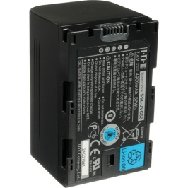The TC400-JVC-650 also features a highly efficient smart charging circuit. “It takes only about 3.5 hours to charge a SSL-JVC50 or SWIT S-8I50 battery pack. The pack can be left on the charger after the charge is complete,” said Dolgin.

For more information visit Dolgin Engineering [www.dolgin.net](http://www.dolgin.net) or call 781 863-1813

